

Motor power calculation for Land Rover 1990 model Defender 110

By

Muhammad Saad

CEO, CST EV

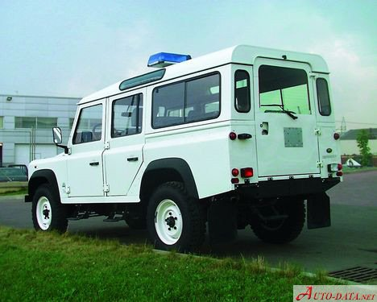

# Parameters

## What engine is in a 1990 Land Rover Defender?

The 1990 Land Rover Defender 110 has a 2.5liter turbo diesel engine (200Tdi) with 122 horsepower at 4200 RPM and 221 lb-ft of torque at 1950 RPM. It has a five-speed manual transmission and all-wheel drive. The 1990 Defender 110 has a top speed of 81 miles per hour (130 kilometers per hour).

Initially held back by the low power of the Land Rover engines (other than the thirsty petrol V8 engine), the 127 benefited from the improvements to the line-up, and by 1990 was only available with the two highest power engines, the 134 hp (100 kW) 3.5-litre V8 petrol, and the 85 hp (63 kW) 2.5-litre turbo diesel.

## How fast is the Defender 110?

>> it has a top speed of 129 mph and can accelerate from 0 to 60 mph in just 7.7 seconds.

Converting a Land Rover Defender to Electric

<https://www.electriccarconverts.com/insights/converting-a-land-rover-defender-to-electric/>

Classic EV Land Rover Defender Conversion Is an Off-Roading Beast

<https://www.youtube.com/watch?v=Z2jZdqeCvTw>

1990 Defender 110 with an Electric Tesla Drivetrain

<https://www.evbuildersguide.com/1990-defender-110-with-an-electric-tesla-drivetrain/>

# Weight of the vehicle after EV conversion

<https://www.auto-data.net/en/land-rover-defender-110-2.5-tdi-107hp-5163>

Gross Weight with passengers: 3050 kg

Fuel tank with full fuel = 90 kg

Battery Weight = 400kg (61.4 kWh)

Engine Weight = 205kg

Range extender = 50kg

Motor kit estimated weight = 60kg (e.g. Hyper 9 IS Motor Kit)

**Gross weight after EV conversion =**

Gross weight of the original vehicle - Engine weight – Fuel tank weight + range extender + Motor kit + Battery

= 3050 kg – 205 kg – 90 kg + 50 kg + 60 kg + 400 kg

= 3,265 kg (includes the passengers weight)

# Total Power usage

**Total Power usage** = Power usage due to air drag force + Power usage due to rolling resistance + Power usage due to the inclination angle of the road

We assume Power usage due to the inclination angle of the road = 0, this will result in a speed decrease on inclined roads but it is normal and also occurs with fuel vehicles.

So the final formula is

**Total Power usage** = Power usage due to air drag force + Power usage due to rolling resistance

Now we discuss the calculation of each of the above resistance forces

# Air drag calculation

Density of the air ρ = 1.225 kg/m3  (at around 15 degrees Celsius, it increase in colder weathers)

<https://en.wikipedia.org/wiki/Density_of_air#:~:text=At%20101.325%20kPa%20(abs)%20and%2015%20%C2%B0C%20(59,62%20lb%2Fcu%20ft)>

Frontal area A estimated by a-c: Av = 3.62 m2

Drag coefficient, Cd = 0.45

|  |
| --- |
|  |

Drag Force = ½ (pCdAV2)

Force constant c for defender 110 = ½ (pCdA) => ½ (1.204 x 0.45 x 3.62) = 0.980658

The air resistance formula can be mathematically stated as:

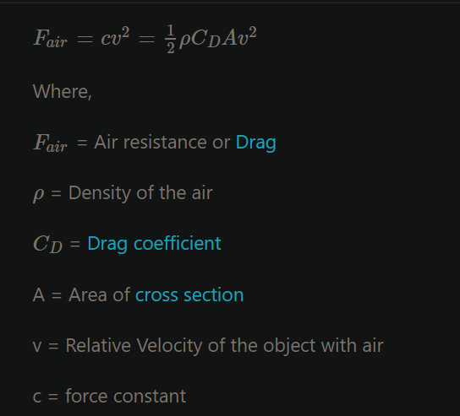

<https://testbook.com/physics-formulas/air-resistance-formula>

We have the formula and data to calculate the drag force acting on the vehicle but we use an online calculator to fill up the table below:

<https://www.omnicalculator.com/physics/drag-equation>

|  |  |  |
| --- | --- | --- |
| **Speed** | **Fair = Drag Force measure in Newtons** | **Power usage due to drag force = Fair x Velocity** |
| 40 km/h (11.11 m/s) | 123.16 N | 1,368.30 W |
| 60 km/h (16.67 m/s) | 277.27 N | 4,622.09 W |
| 80 km/h (22.22 m/s) | 492.6 N | 10,945.57 W |
| 90 km/h (25 m/s) | 623.6 N | 15,590 W |
| 100 km/h (27.78 m/s) | 770 N | 21,390.6 W |
| 120 km/h (33.33 m/s) | 1108.4 N | 36,942.97 W |

## Example of drag force calculation at 120 km/h (33.33 m/s) using the online calculator

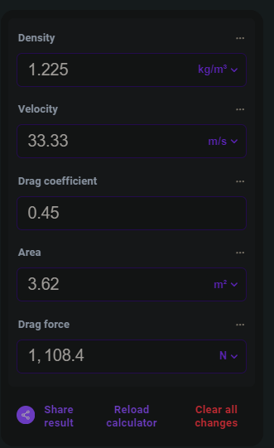

**Power usage due to drag force** = Drag force x the velocity of the vehicle = ½ (pCAV2) x V = ½ pCAV3

For example, the Power usage due to drag force at 60 km/h (16.67 m/s) = 0.5 x 1.204 x 0.45 x 3.62 x 16.673 = 4,542 Watts

Please note that the power usage due to the drag force acting on the vehicle increases as cube of the current velocity/speed so the higher the speed the higher the power usage. The power usage increases exponentially with speed so therefore we limit the EV top speed to 120 km/h.

# Rolling Resistance

This is the resistance to the motion of the car's tires as they roll on the road. It's influenced by factors like weight of the vehicle, tire type, road surface, and tire pressure.

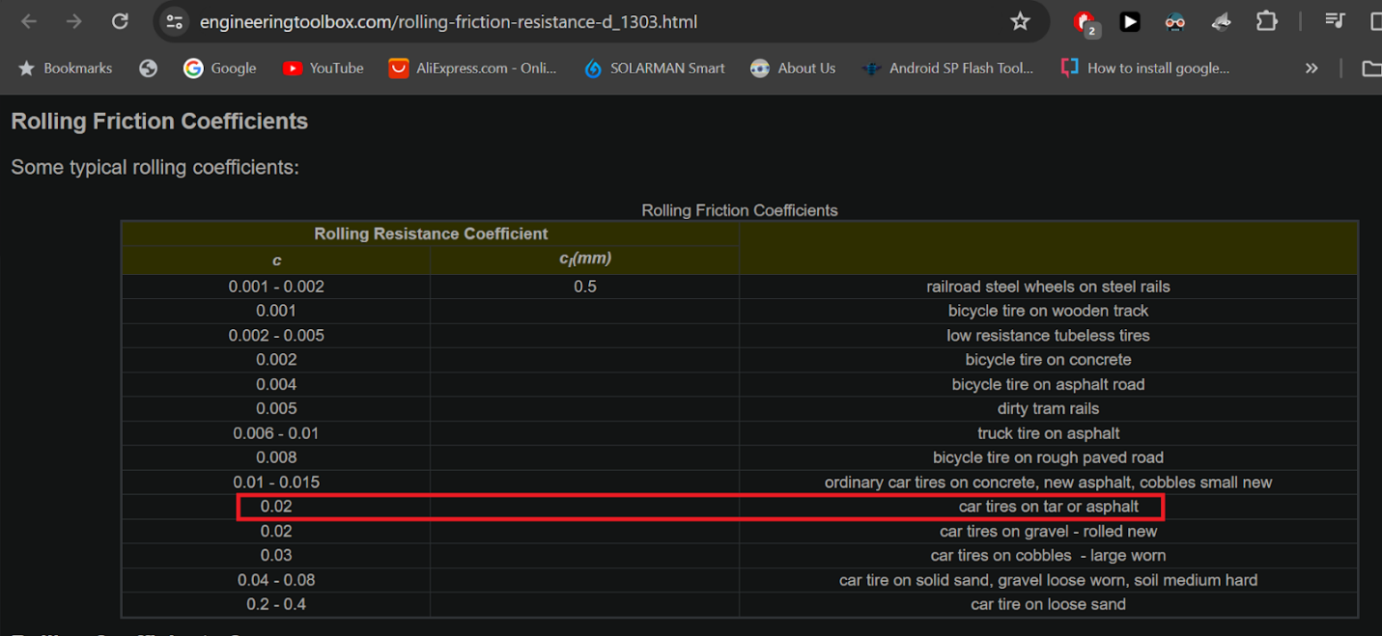

Table taken from <https://www.engineeringtoolbox.com/rolling-friction-resistance-d_1303.html>

Here is an online calculator for calculating the rolling resistance force

<https://www.omnicalculator.com/physics/rolling-resistance#rolling-resistance-basics>

Weight of Defender 110 after EV conversion = 3,265 kg

Rolling resistance = 640.6 N

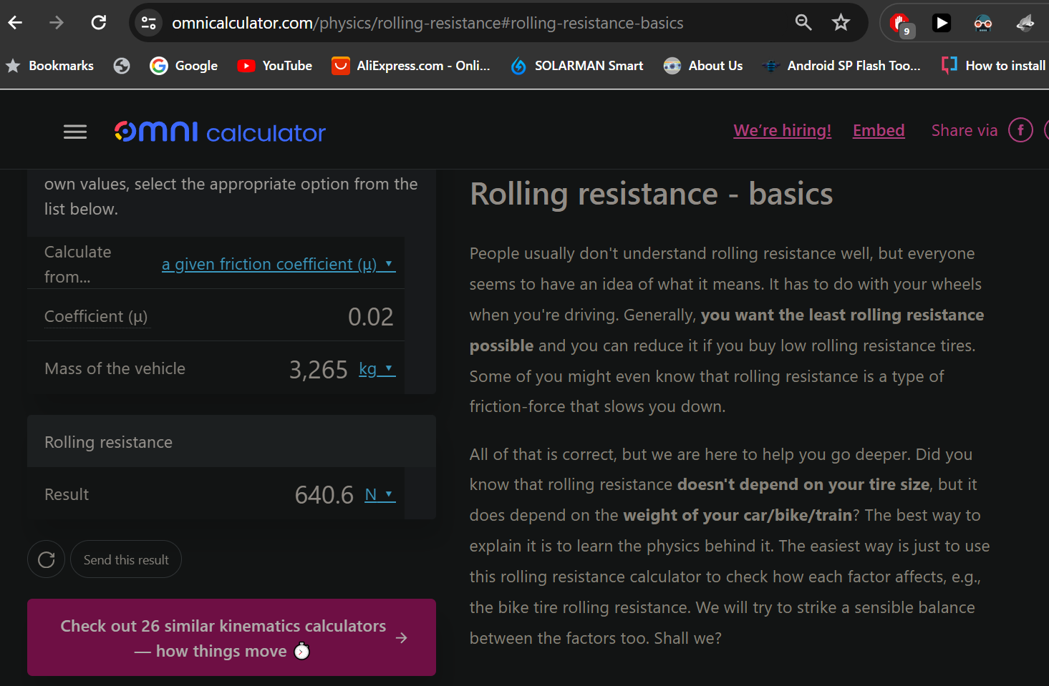

|  |  |  |
| --- | --- | --- |
| **Speed** | **Rolling Resistance Force** | **Power usage due to rolling resistance = RR x Velocity** |
| 40 km/h (11.11 m/s) | 640.6 N | 7,117.06 W |
| 60 km/h (16.67 m/s) | 640.6 N | 10,678.80 W |
| 80 km/h (22.22 m/s) | 640.6 N | 14,234.13 W |
| 90 km/h (25 m/s) | 640.6 N | 16,015 W |
| 100 km/h (27.78 m/s) | 640.6 N | 17,795.86 W |
| 120 km/h (33.33 m/s) | 640.6 N | 21,351.19 W |

# Land Rover 1990 Defender 110 calculation for motor power vs speed

|  |  |  |  |  |  |
| --- | --- | --- | --- | --- | --- |
| **Speed** | **Drag Force** | **Power usage due to drag force** | **Rolling Resistance Force** | **Power usage due to rolling resistance** | **Total Power usage** |
| 40 km/h (11.11 m/s) | 123.16 N | 1,368.30 W | 640.6 N | 7,117.06 W | 8,485.36 W |
| 60 km/h (16.67 m/s) | 277.27 N | 4,622.09 W | 640.6 N | 10,678.80 W | 15,300.89 W |
| 80 km/h (22.22 m/s) | 492.6 N | 10,945.57 W | 640.6 N | 14,234.13 W | 25,179.7 W |
| 90 km/h (25 m/s) | 623.6 N | 15,590 W | 640.6 N | 16,015 W | 31,605 W |
| 100 km/h (27.78 m/s) | 770 N | 21,390.6 W | 640.6 N | 17,795.86 W | 39,186.46 W |
| 120 km/h (33.33 m/s) | 1108.4 N | 36,942.97 W | 640.6 N | 21,351.19 W | 58,294.16 W |

There are 20-25% losses in transmission, clutch disk, ball bearings, motor inefficiency etc. so we adjust the motor power to be 20% higher than the power usage.

|  |  |  |  |  |
| --- | --- | --- | --- | --- |
| **Speed** | **Total Power usage** | **Motor power needed = 20% higher than power usage** | **Energy usage per km** | **Mileage per charge on a 61.4 kWh battery** |
| 40 km/h (11.11 m/s) | 8,485.36 W | 10.18 kW | 254.5 Wh/km | 241 km |
| 60 km/h (16.67 m/s) | 15,300.89 W | 18.36 kW | 306 Wh/km | 200 km |
| 80 km/h (22.22 m/s) | 25,179.7 W | 30.22 kW | 377.75 Wh/km | 162.5 km |
| 90 km/h (25 m/s) | 31,605 W | 37.92 kW | 421.3 Wh/km | 146 km |
| 100 km/h (27.78 m/s) | 39,186.46 W | 47.02 kW | 470.2 Wh/km | 130.5 km |
| 120 km/h (33.33 m/s) | 58,294.16 W | 69.95 kW | 582.9 Wh/km | 105 km |

The higher the speed, the higher the power usage and thus lower the range.

# Conclusion

A PMSM motor rated for 45kW should be enough to run the defender 110 at 100 km/h for 130.5km with a 61.4kWh battery. The peak power of such motors is usually double the rated power but we will consider the rated power because the motor if run at peak power continuously can get damaged.

# Power consumption and hence motor power requirement increases with speed

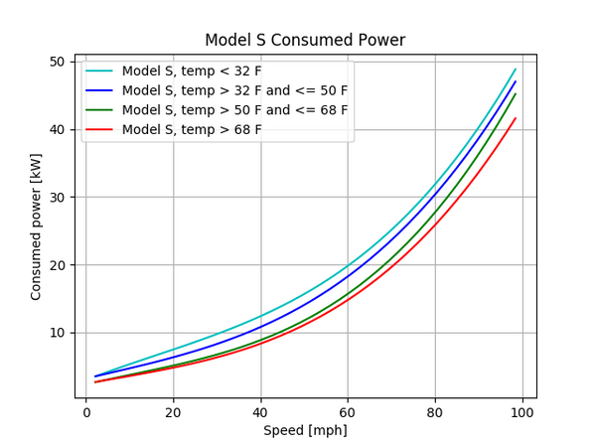

# The range decreases at higher speeds

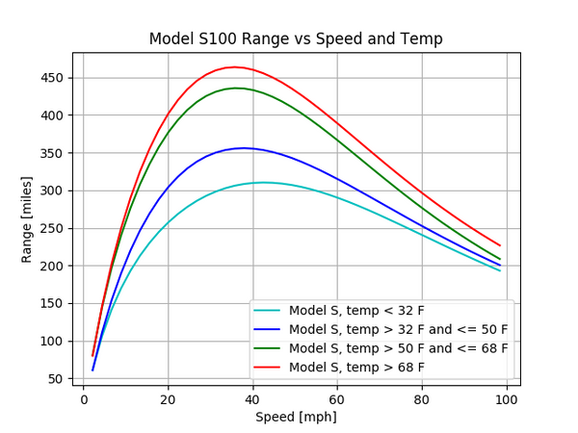

Graphs taken from <https://cleantechnica.com/2018/07/15/tesla-range-plotted-relative-to-speed-temperature-graphs/>

Motor kit purchace link:

<https://www.alibaba.com/product-detail/60kW-PMSM-Motor-for-Electric-Vehicle_60834641403.html>

<https://sumcont.en.alibaba.com/?spm=a2700.12243863.0.0.4d523e5fC2U7J4>

<https://huifeng-motor.en.alibaba.com/?spm=a2700.12243863.0.0.4d523e5fC2U7J4>

60kW PMSM Motor Driving Kit for Electric Vehicle

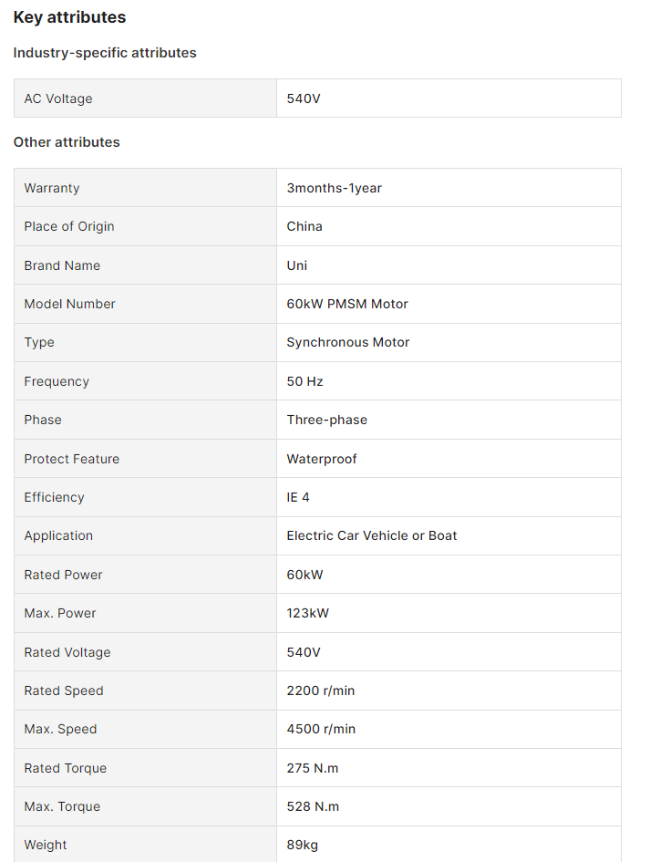

Nissan leaf

<https://www.nissanusa.com/vehicles/electric-cars/leaf/features.html>

Two battery options for thrilling drives

### 40 kWh battery Lithium ion: Nissan LEAF

### 60 kWh battery: Nissan LEAF SV PLUS

Nissan LEAF’s standard 40 kWh battery delivers instant acceleration and up to 149 EPA-estimated miles on a single charge—powering you through daily commutes with room to spare.

Using the 50 kW quick charge port, a 40 kWh battery can be charged to 80% in 40 minutes, while a 60 kWh battery can achieve the same level in 60 minutes.

<https://www.nissanusa.com/vehicles/electric-cars/leaf/specs-trims.html#modelName=S|40%20kWh%20lithium-ion%20battery>

